**Business requirements**

**Project «Agriculture exchange»**

**Version 3.0**

**25.04.2022**

**Author: Fazilat Allayarova**

Contents

Versions 3

Business Requirements 3

Initial data 3

Business opportunities 3

Business goals 3

Success criteria 4

Business-risks 4

Operating environment 4

Functional requirements specification 4

USER FLOW 5

Main user functions 6

Minimum Viable Product (MVP) 7

Limitations and exclusions 7

Assumptions 8

USER PATH (Features) 8

References 12

## Versions

|  |  |  |  |
| --- | --- | --- | --- |
| Name | Date | Change reason | Version |
| Fazilat Allayarova | 21.02.2022 | Creation of Vision and Scope | 1.0 |
| Fazilat Allayarova | 28.03.2022 | Edited | 2.0 |
| Fazilat Allayarova | 25.04.2022 | Edited | 3.0 |

# Business Requirements

## Initial data

Agriculture is the leading sector of the economy of Uzbekistan. The share of the industry in the gross domestic product of the Republic is 26.1%. Currently, the country is actively developing the production and export of vegetables, fruits and other agriculture products.

In Uzbekistan, 90.3% of all agricultural production falls on the non-state sector. There are about 80.1 thousand farms in the country, with more than 3.8 million hectares of land assigned to them.

The main crops grown are vegetables, grains and fruits. The climatic conditions of Uzbekistan favor the development of horticulture and viticulture. Uzbek vegetables, fruits and grapes are in demand and exported to many CIS countries (Agroexport, 2021).

The main importers of fruits and vegetables from Uzbekistan are Russia (31.5% of total exports), Kazakhstan (20.9%), Kyrgyzstan (13.2%), China (9.9%), Pakistan, Afghanistan (Goskomstat, 2021) .

## Business opportunities

Today, there are several trading platforms, such as the Commodity Exchange (uzex.uz), the Chamber of Commerce and Industry, as well as a number of private companies for the export of agriculture products (see Appendix 1). However, not every private farmer has the opportunity to sell their products on foreign markets due to bureaucratic restrictions and lack of information.

The B2B platform will act as an exchange designed to promote the products of local (Uzbek) manufacturers engaged in the agricultural industry to foreign markets.

This platform allows local producers to post ads on agricultural products, as well as buyers from neighboring countries to have access to the agricultural market of Uzbekistan.

The platform will also offer product quality control service, logistics service, export consultation.

## Business goals

On agricultural products trade market in Uzbekistan there is no open, non-state electronic trading platform for the sale of local agricultural products in foreign markets. There are no applications in Uzbekistan that will allow sellers to display their products, and buyers to have access to a wide selection of agricultural products in a single place. Also, a number of services (documentation, quality control, logistics) will be available to all participants of the platform, serving as a “single window” for the successful finalization of the transaction.

## Success criteria

1. MVP release in 2 months
2. The application is available in mobile and web versions
3. Revenue will be generated from each transaction and additional. services (% of the transaction value) *(next releases provide for the development of online payments and the offer of additional services), external advertisements
4. The application will bring together sellers of agricultural products of Uzbekistan in a single place
5. First clients with successful transactions in the first year after the release

## Business-risks

|  |  |  |
| --- | --- | --- |
| **Risks** | **Risk level** | **Risk mitigation actions** |
| Integration with the payment system | High |  |
| Availability of competitive platforms and services | Low |  |
| Protection of personal data of clients | High |  |
| Problems of acceptance of the new system by the exchange participants | Middle |  |
| State regulation, export quotas | High |  |
| Quality inconsistency | High |  |

## Operating environment

• The application has mobile and web versions;

• The application is being developed for use mainly in the market of Uzbekistan, the CIS, Asia and Europe;

• The application assumes five roles: guest, registered user seller, registered user buyer, system administrator and exchange employee;

• Data privacy is important as users will enter their personal information.

## Functional requirements specification

The main purpose of the agricultural exchange application is the ability for sellers of agricultural products to quickly and easily place their ads. On the other hand, exporters, importers and distributors can choose the product and bargain. Further, customers can pay online and request other services (consultation, documentation).

Deal stages (main services)

1. Offer of goods (seller, buyer)
2. The seller and buyer can exchange standard messages (on price, quantity, other characteristics of product)
3. Employee of the exchange platform can communicate with the customer to finalize transaction
4. Customer applies for other services for the final transaction, such as:

• Consulting on exports operations and documentation

• Quality control of products (according to the specification from the buyer, audit on site to the seller)

• Logistics (calculation of the cost of transportation, other conditions)

5. Payment

## USER FLOW

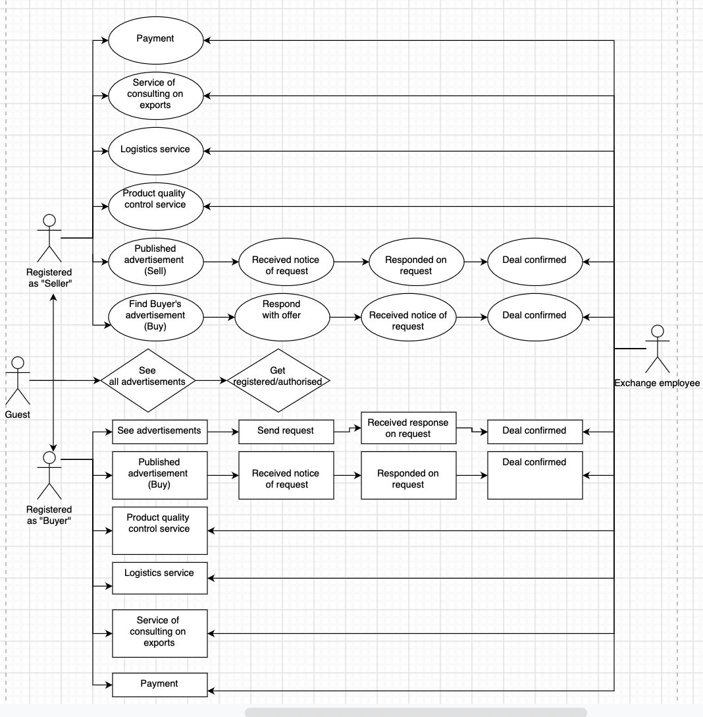

## Main user functions

Guest functions:

F-1 Enter web page/app  
F-2 View advertisements

F-3 Search for advertisements using filters

F-4 Registration/Authorization

Seller functions:

F-1 Enter web page/app  
F-2 View advertisements

F-3 Search for advertisements using filters

F-4 Registration/Authorization

F-5 View user profile/personal account (information about personal data, notifications)

F-6 Edit user profile/personal account

F-7 Enable/disable notifications (sms notifications, email notifications and push notifications (push notifications for mobile version only)

F-8 Change account password

F-9 Placing an advertisement (with options Sell/Buy, product category, type, other product characteristics, quantity, price)

F-10 Editing advertisement placement (changing product characteristics)

F-11 Option to receive notifications from the buyer

F-12 Option to respond to the buyer's request

F-13 Option to confirm the order

F-14 Online payment option

F-15 Option to submit a request for a logistics service

F-16 Option to request a quality control service

F-17 Option to request an export consultation service

Buyer functions:

F-1 Enter web page/app  
F-2 View advertisements

F-3 Search for advertisements using filters

F-4 Registration/Authorization

F-5 View user profile/personal account (information about personal data, notifications)

F-6 Edit user profile/personal account

F-7 Enable/disable notifications (sms notifications, email notifications and push notifications (push notifications for mobile version only)

F-8 Change account password

F-9 Placing an advertisement (with options Sell/Buy, product category, type, other product characteristics, quantity, price)

F-10 Editing advertisement placement (changing product characteristics)

F-11 Option to receive notifications from the seller

F-12 Option to respond to the seller's request

F-13 Option to confirm the order

F-14 Online payment option

F-15 Option to submit a request for a logistics service

F-16 Option to request a quality control service

F-17 Option to request an export consultation service

Platform for administrator:

F-1 Login and password. Authorization using a personal login and password.

F-2 Sellers. The section allows you to manage the records of the sellers database.

F-3 Buyers. This section allows you to manage customer database records.

F-4 Notifications. The section allows you to manage existing and create new types of notifications.

F-5 Advertisements. The section contains information about all ads and their characteristics. Allows you to manage information in the database, as well as import and export data.

F-6 Settings. Allows you to adjust the operation of the system.

## Minimum Viable Product (MVP)

The MVP must be produced and delivered within 2 months of the start of the project:

* Application for clients with following functions

-Enter web page/app  
-View advertisements

-Search for advertisements using filters

-Registration/Authorization

-View user profile/personal account (information about personal data, email, notifications)

-Edit user profile/personal account

-Change account password

-Placing an advertisement (with options Sell/Buy, product category, type, other product characteristics, quantity, price)

-Editing advertisement placement (changing product characteristics)

-Receive notifications from the seller

-Responding to the seller's request

-Option to confirm the order

* Administrator’s platform (moderating advertisements with approve/disapprove function)

Composition of subsequent releases of the system

The following features are planned for future releases:

* -Option of Premium status for the advertisement available (charged service)
* Enable/disable notifications (sms notifications, email notifications and push notifications (push notifications for mobile version only)
* Administrator’s platform (elaboration)
* Users will be able to make online payments
* Users will be able to leave requests for additional services
* Users will be able to leave feedback/rate about sellers and buyers;
* Users will be able to view order history

## Limitations and exclusions

• The exchange application does not include chats for communication between staff and customers (still under consideration).

• No possibility to register via social networks (Google, Facebook)

• Only one account can be created per phone number.

## Assumptions

• The application is available to any user who downloads it or uses online.

• The application is available in Russian, Uzbek and English.

• The legislation of the Republic of Uzbekistan allows the sale of agricultural products through an online order with delivery and pickup.

• The legislation of the Republic of Uzbekistan allows paying in advance for the order during the transaction.

• The exchange has all the necessary resources to provide new functionality: logistics services, documentation, quality control.

## WEB USER PATH (Features)

1. ADVERTISEMENTS

2. PUBLISH ADVERTISEMENT

3. OUR SERVICES

4. About us

5. Contacts

MAIN PAGE (GUEST)

1.ADVERTISEMENTS



On top of all pages there is

an option to choose the currency,

Log in, Register, Language (Eng, Rus, Uzb)

* 1. PRODUCT CATEGORIES ->PRODUCT TYPE -> FRESH FRUITS -> APPLES, GRAPES ETC

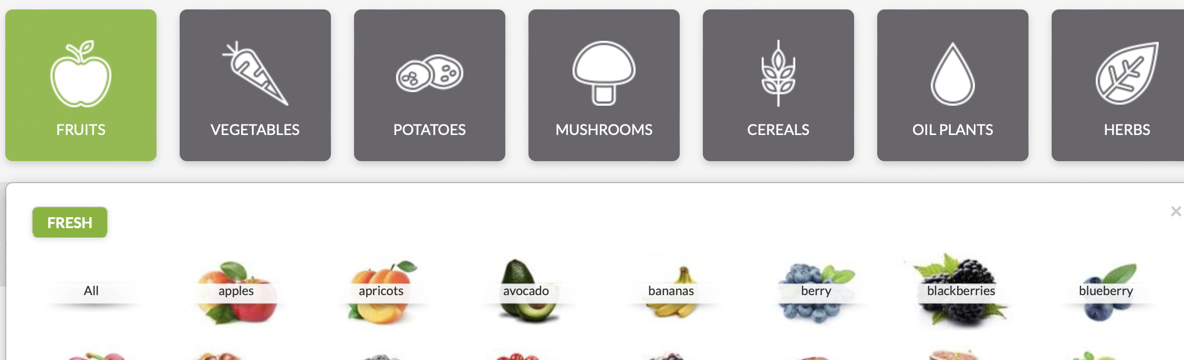

When choosing the product type, all adds for this product type pop up in the list, and filter appears with all product characteristics (price, size, sort, color, width, etc. depending on a product (each product will have its own set of characteristics)

->APPLES-> list of selected fruit type

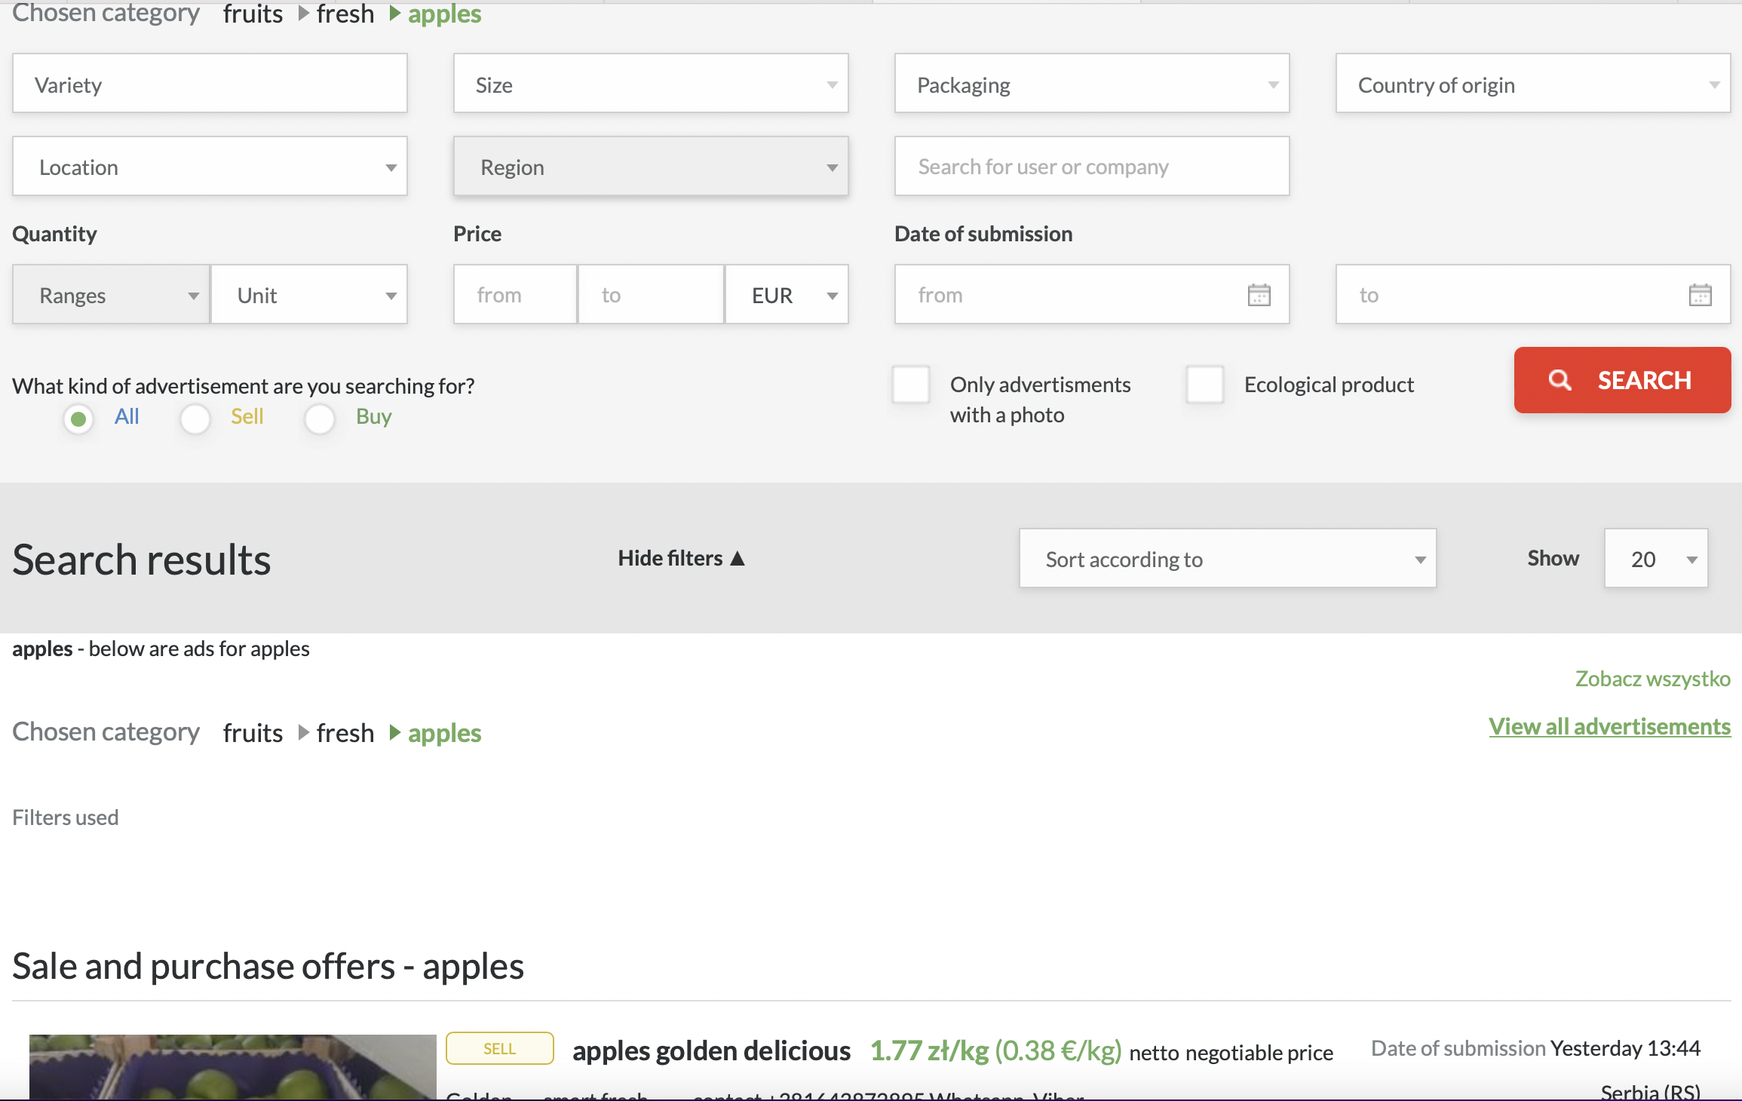

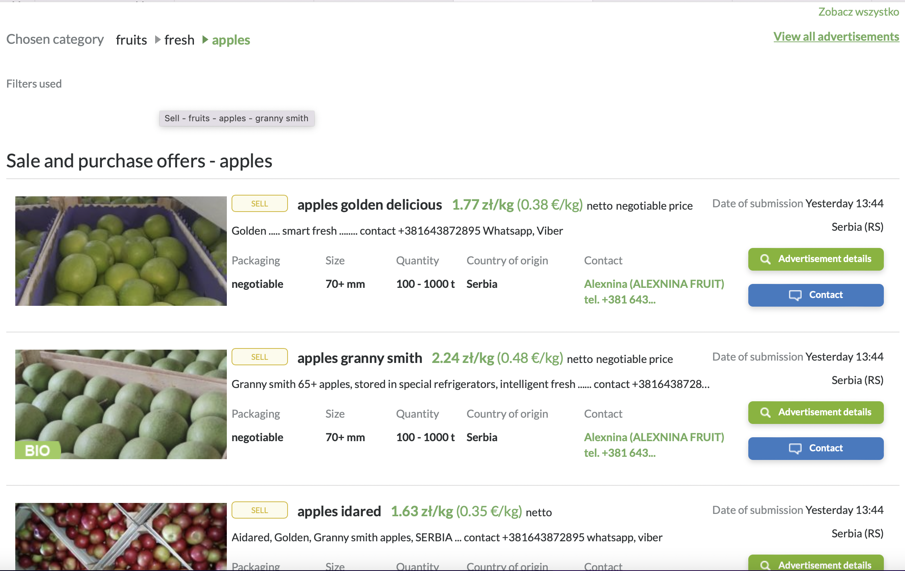

There is an option to see the details of each ad.

Second half of the main page lists the newest advertisements with an option to see the details of each ad.

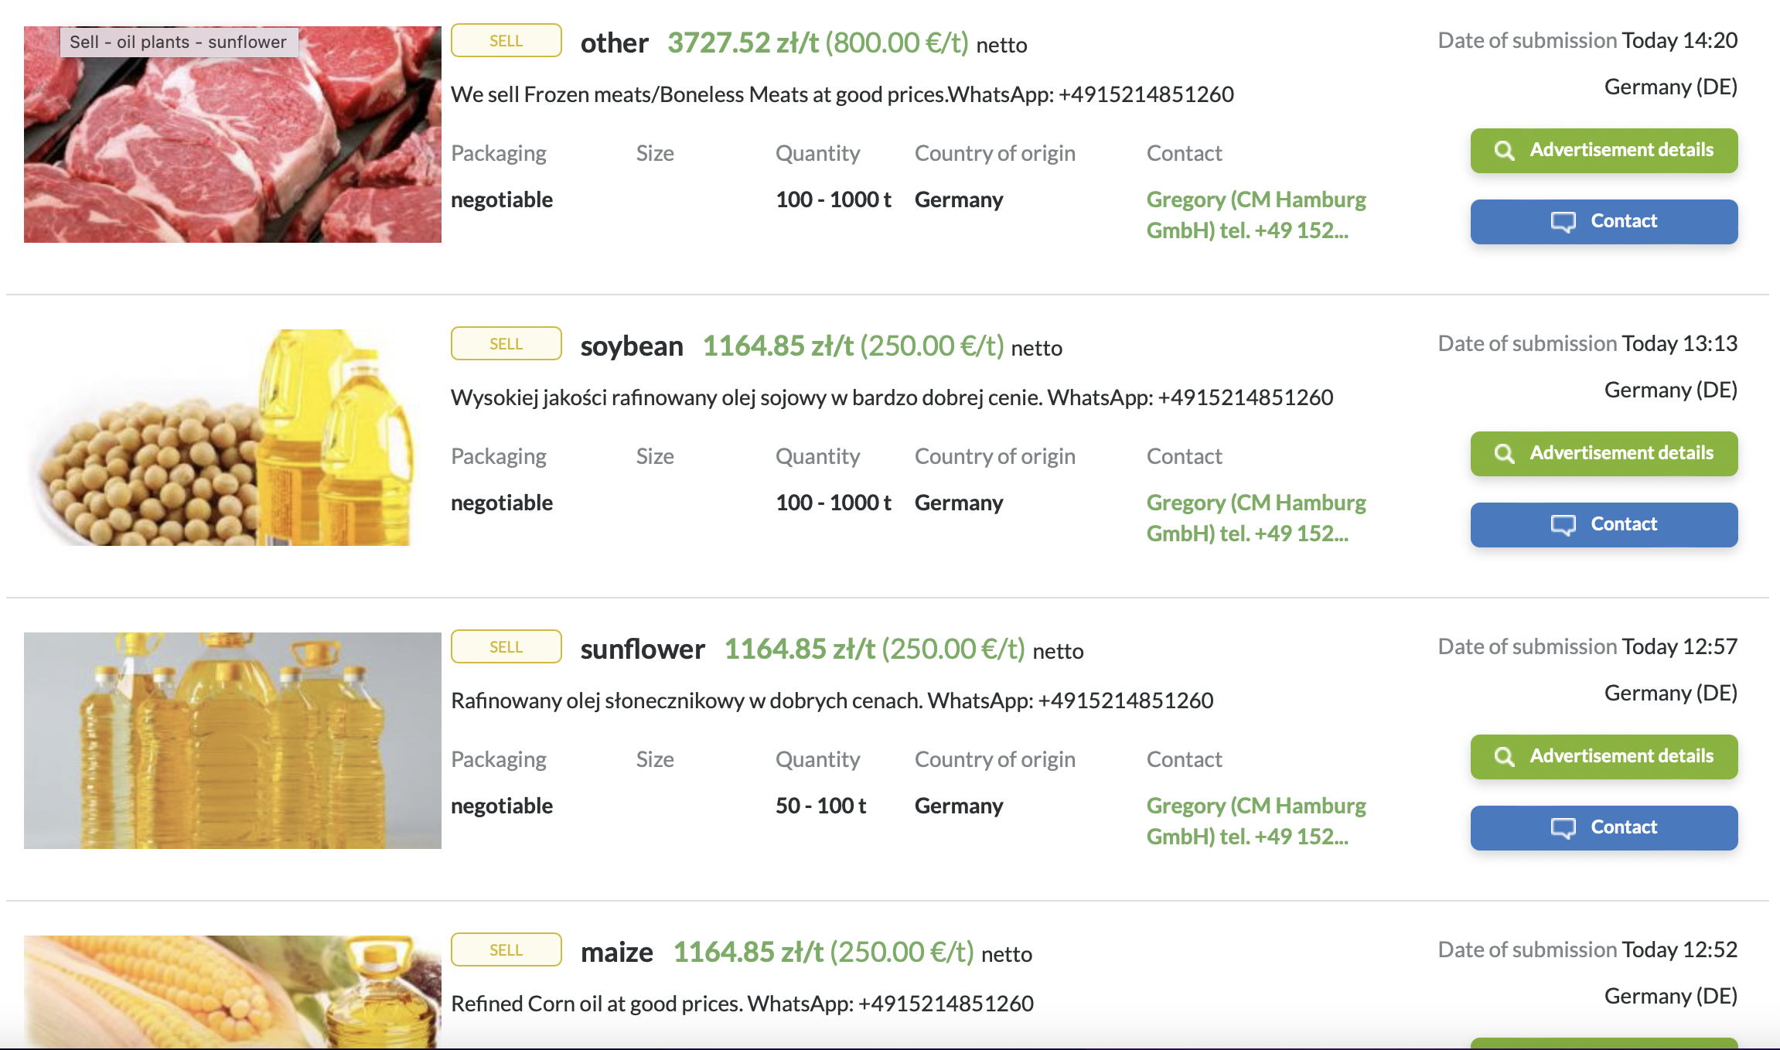

1.2 Advertisement detail

Here the user has an option to ORDER, so is directed to Registration/authorization page (for Guest) otherwise (for registered user) proceeds to ORDER for submitting the request

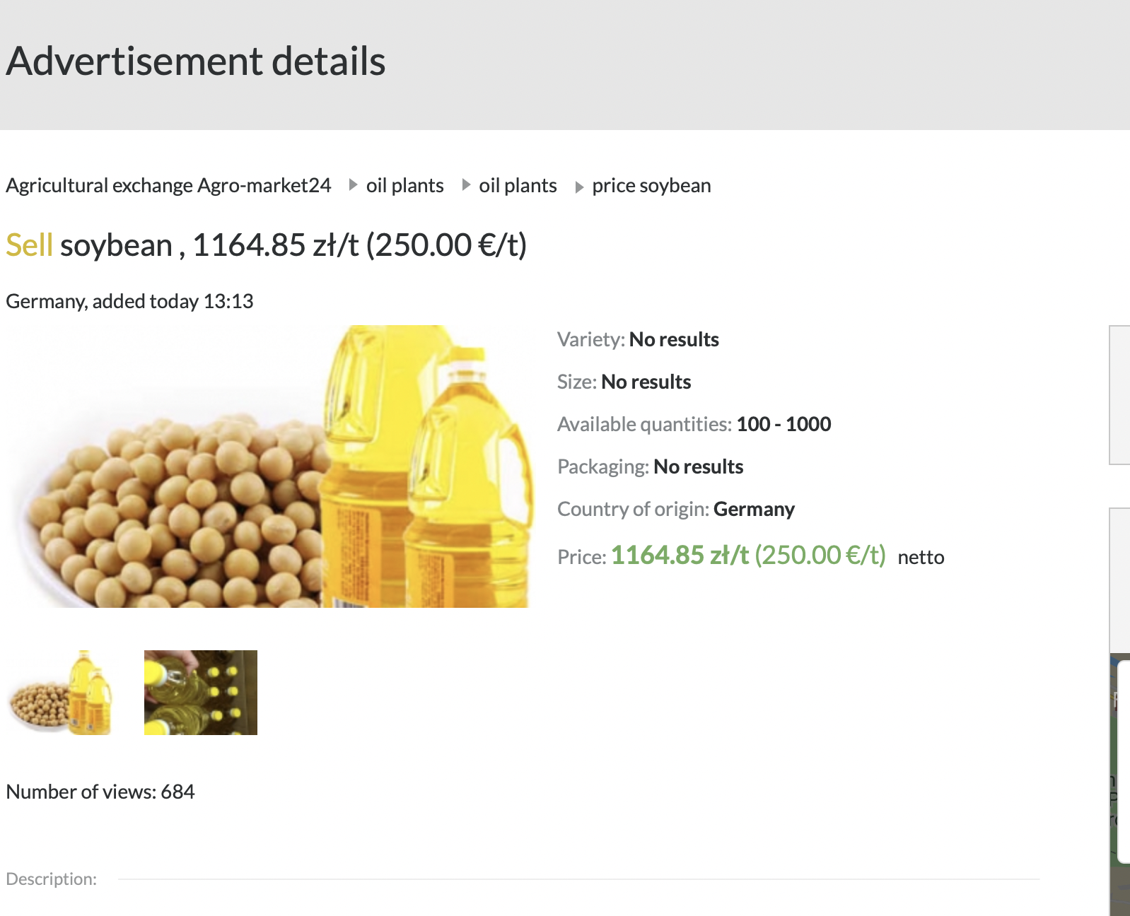

1.3 Submit order

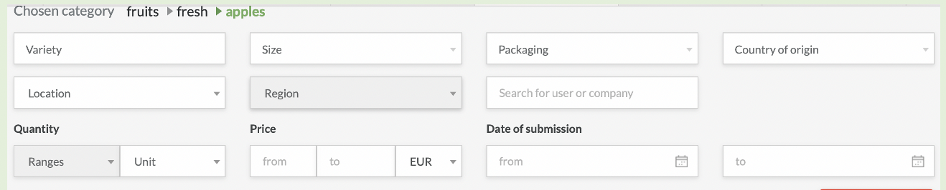

Register

Users fill in the “Registration” form;

First name, last name, e-mail address/phone number and password are required to enter;

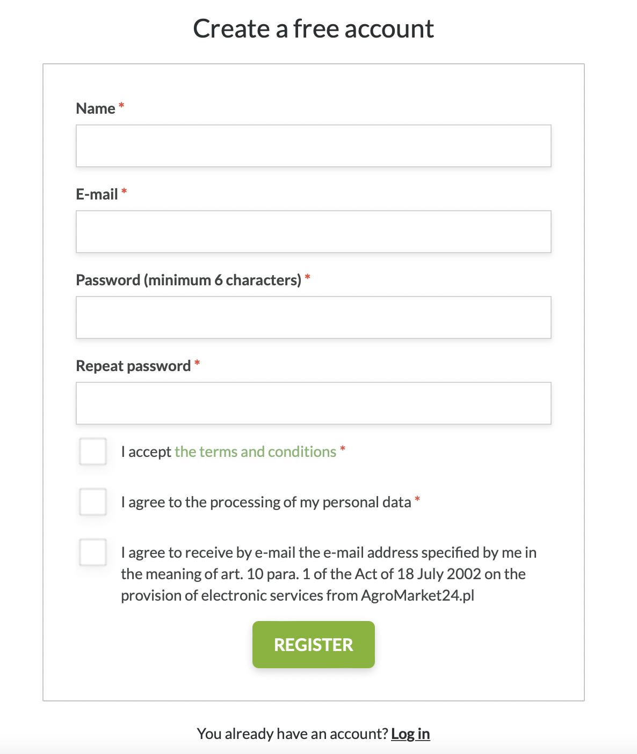

Log in

Users fill out an authorization form;

Email/phone number and password are requested for input;

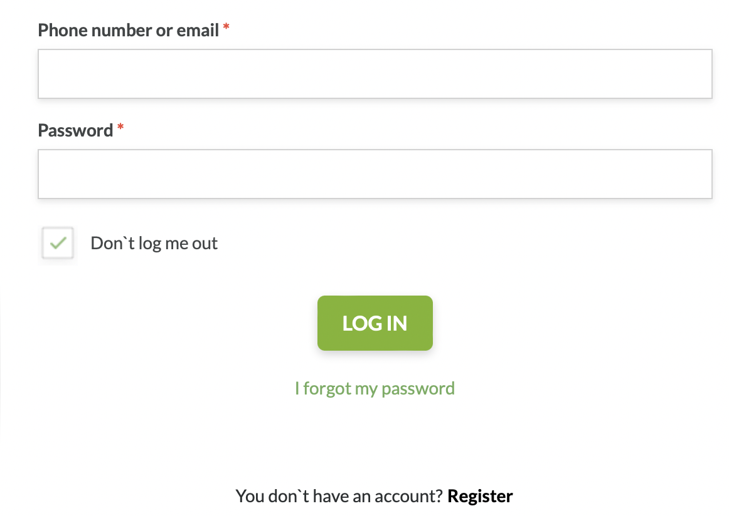

(Log out:

Users log out of their personal account by clicking on the “Logout” button)

2. Publish Advertisement

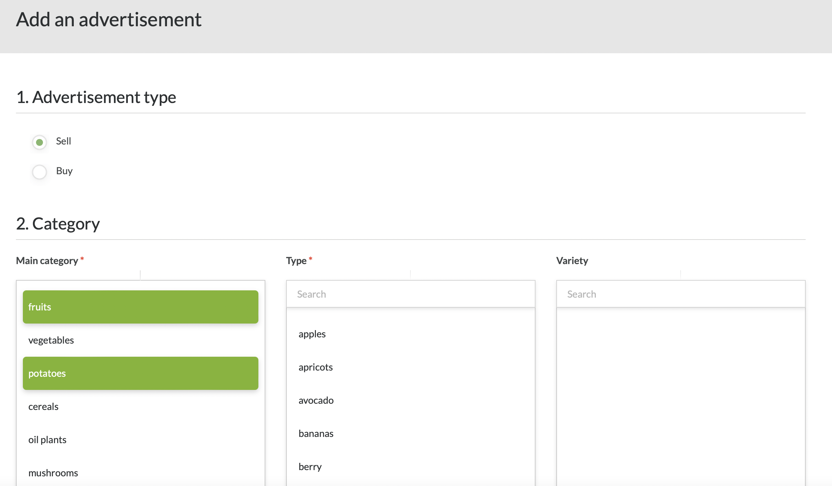

Web user path is due for further elaboration.

Attachment 1

Private companies for the export of fruits and vegetables

* Exim Agro, specializing in the export of fruits and vegetables. <https://eximagro.uz>
* Fruit Exim is an export company operating in the B2B segment, with the aim of supplying high-quality fresh fruits and vegetables from Uzbekistan. [www.fruitexim.com](http://www.fruitexim.com)
* "GLOBAL EXPORT COMPANY" is a specialized company for harvesting, processing and export of legumes. It also exports a wide range of fruits and vegetables, textiles, consumer goods, as well as imports products not produced in Uzbekistan. [www.globalex.uz](http://www.globalex.uz)
* "SUNFINITE" are engaged in the export of fruits, vegetables and legumes from Uzbekistan. [www.sunfinite.com](http://www.sunfinite.com)
* "AGROLICOR GROUP" [www.agrolicor.com](http://www.agrolicor.com)

## References

Agroexport,2021 <https://mcx.gov.ru/upload/iblock/5db/5dbc0f972068d0fd255da3a6bdd1357b.pdf>